0.0

training 1 epoch...

244.47685599327087 seconds used......

1 training finished! average train loss: 0.6104666386514431

total clf loss: 270.4367209225893 total adv loss: 158.05838007852435

evaluating...

Confusion matrix, without normalization

[[ 670 180 142]

[ 718 4551 140]

[1003 285 9504]]

Normalized confusion matrix

[[0.67540323 0.18145161 0.14314516]

[0.13274173 0.84137549 0.02588279]

[0.09293921 0.02640845 0.88065234]]

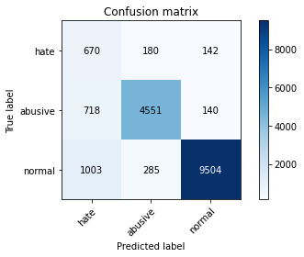

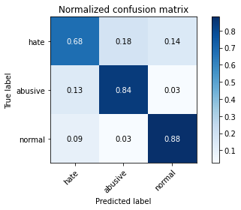

precision recall f1-score support

hate 0.28 0.68 0.40 992

abusive 0.91 0.84 0.87 5409

normal 0.97 0.88 0.92 10792

accuracy 0.86 17193

macro avg 0.72 0.80 0.73 17193

weighted avg 0.91 0.86 0.88 17193

average eval_loss: 0.4289126700006945, accuracy: 0.8564532077008085

training 2 epoch...

244.4588747024536 seconds used......

2 training finished! average train loss: 0.4451681102035277

total clf loss: 197.20947282016277 total adv loss: 121.23718020692468

evaluating...

Confusion matrix, without normalization

[[ 743 124 125]

[1069 4172 168]

[1436 187 9169]]

Normalized confusion matrix

[[0.74899194 0.125 0.12600806]

[0.19763357 0.77130708 0.03105935]

[0.13306153 0.01732765 0.84961082]]

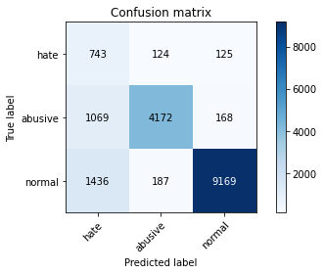

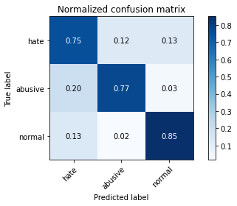

precision recall f1-score support

hate 0.23 0.75 0.35 992

abusive 0.93 0.77 0.84 5409

normal 0.97 0.85 0.91 10792

accuracy 0.82 17193

macro avg 0.71 0.79 0.70 17193

weighted avg 0.91 0.82 0.85 17193

average eval_loss: 0.4807255659772213, accuracy: 0.8191705926830687

0.1

training 1 epoch...

244.59082078933716 seconds used......

1 training finished! average train loss: 0.639034656854031

total clf loss: 267.5892997533083 total adv loss: 155.03054246678948

evaluating...

Confusion matrix, without normalization

[[ 649 186 157]

[ 656 4593 160]

[ 945 268 9579]]

Normalized confusion matrix

[[0.65423387 0.1875 0.15826613]

[0.12127935 0.84914032 0.02958033]

[0.08756486 0.02483321 0.88760193]]

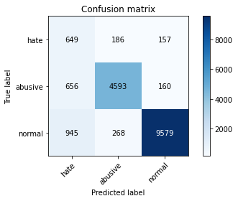

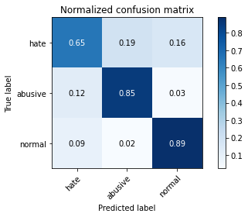

precision recall f1-score support

hate 0.29 0.65 0.40 992

abusive 0.91 0.85 0.88 5409

normal 0.97 0.89 0.93 10792

accuracy 0.86 17193

macro avg 0.72 0.80 0.73 17193

weighted avg 0.91 0.86 0.88 17193

average eval_loss: 0.3983581977788099, accuracy: 0.862036875472576

training 2 epoch...

244.83004355430603 seconds used......

2 training finished! average train loss: 0.46759223256840393

total clf loss: 195.13531011343002 total adv loss: 120.08048940449953

evaluating...

Confusion matrix, without normalization

[[ 767 120 105]

[1032 4268 109]

[1768 241 8783]]

Normalized confusion matrix

[[0.77318548 0.12096774 0.10584677]

[0.19079312 0.78905528 0.0201516 ]

[0.16382506 0.02233136 0.81384359]]

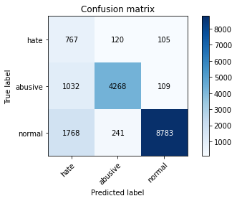

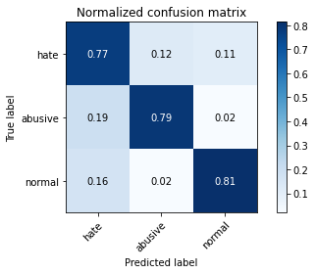

precision recall f1-score support

hate 0.22 0.77 0.34 992

abusive 0.92 0.79 0.85 5409

normal 0.98 0.81 0.89 10792

accuracy 0.80 17193

macro avg 0.70 0.79 0.69 17193

weighted avg 0.92 0.80 0.84 17193

average eval_loss: 0.5313449598242377, accuracy: 0.803699179898796

0.2

training 1 epoch...

244.75179266929626 seconds used......

1 training finished! average train loss: 0.6829416046158724

total clf loss: 270.8719836175442 total adv loss: 158.35573539882898

evaluating...

Confusion matrix, without normalization

[[ 786 98 108]

[1385 3928 96]

[1562 233 8997]]

Normalized confusion matrix

[[0.79233871 0.09879032 0.10887097]

[0.25605472 0.72619708 0.0177482 ]

[0.14473684 0.02159007 0.83367309]]

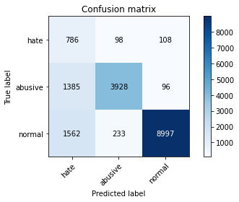

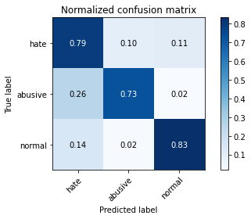

precision recall f1-score support

hate 0.21 0.79 0.33 992

abusive 0.92 0.73 0.81 5409

normal 0.98 0.83 0.90 10792

accuracy 0.80 17193

macro avg 0.70 0.78 0.68 17193

weighted avg 0.92 0.80 0.84 17193

average eval_loss: 0.524132958825591, accuracy: 0.7974757168615134

training 2 epoch...

244.7190351486206 seconds used......

2 training finished! average train loss: 0.4994036331940989

total clf loss: 197.41396862268448 total adv loss: 119.1092038936913

evaluating...

Confusion matrix, without normalization

[[ 642 225 125]

[ 541 4779 89]

[1407 435 8950]]

Normalized confusion matrix

[[0.64717742 0.22681452 0.12600806]

[0.10001849 0.88352745 0.01645406]

[0.13037435 0.04030764 0.82931801]]

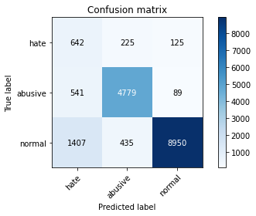

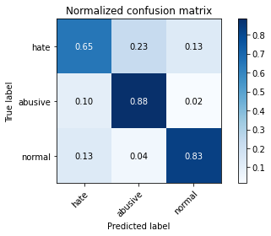

precision recall f1-score support

hate 0.25 0.65 0.36 992

abusive 0.88 0.88 0.88 5409

normal 0.98 0.83 0.90 10792

accuracy 0.84 17193

macro avg 0.70 0.79 0.71 17193

weighted avg 0.90 0.84 0.86 17193

average eval_loss: 0.4528025716976371, accuracy: 0.8358634327924155

0.30000000000000004

training 1 epoch...

244.847421169281 seconds used......

1 training finished! average train loss: 0.699364957670864

total clf loss: 263.7623831778765 total adv loss: 153.520970094949

evaluating...

Confusion matrix, without normalization

[[ 711 154 127]

[ 837 4484 88]

[1270 421 9101]]

Normalized confusion matrix

[[0.71673387 0.15524194 0.12802419]

[0.1547421 0.82898872 0.01626918]

[0.11767976 0.03901038 0.84330986]]

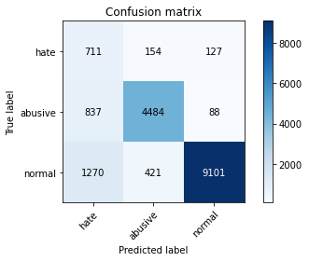

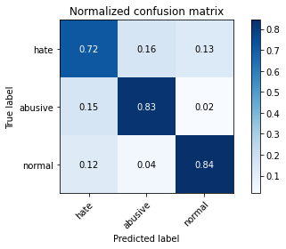

precision recall f1-score support

hate 0.25 0.72 0.37 992

abusive 0.89 0.83 0.86 5409

normal 0.98 0.84 0.91 10792

accuracy 0.83 17193

macro avg 0.71 0.80 0.71 17193

weighted avg 0.91 0.83 0.86 17193

average eval_loss: 0.48866020328430243, accuracy: 0.8315011923457221

training 2 epoch...

244.69081783294678 seconds used......

2 training finished! average train loss: 0.5255284682420791

total clf loss: 197.04660994559526 total adv loss: 119.20833280682564

evaluating...

Confusion matrix, without normalization

[[ 723 144 125]

[ 935 4380 94]

[1470 329 8993]]

Normalized confusion matrix

[[0.72883065 0.14516129 0.12600806]

[0.17286005 0.80976151 0.01737844]

[0.13621201 0.03048554 0.83330245]]

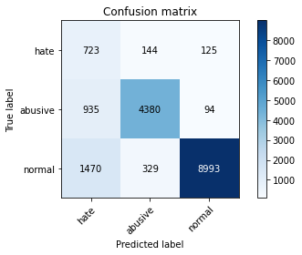

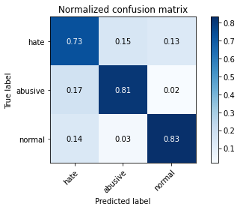

precision recall f1-score support

hate 0.23 0.73 0.35 992

abusive 0.90 0.81 0.85 5409

normal 0.98 0.83 0.90 10792

accuracy 0.82 17193

macro avg 0.70 0.79 0.70 17193

weighted avg 0.91 0.82 0.85 17193

average eval_loss: 0.4940995565074128, accuracy: 0.8198685511545396

0.4

training 1 epoch...

244.65584540367126 seconds used......

1 training finished! average train loss: 0.7392693437114526

total clf loss: 266.48776264488697 total adv loss: 152.52138943970203

evaluating...

Confusion matrix, without normalization

[[ 773 126 93]

[1129 4191 89]

[2096 282 8414]]

Normalized confusion matrix

[[0.77923387 0.12701613 0.09375 ]

[0.2087262 0.77481974 0.01645406]

[0.19421794 0.02613047 0.77965159]]

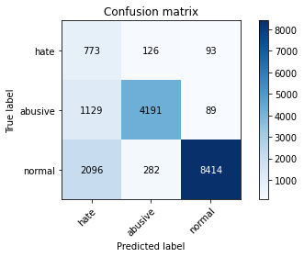

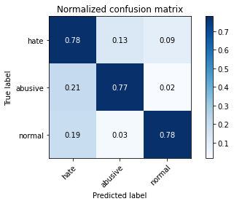

precision recall f1-score support

hate 0.19 0.78 0.31 992

abusive 0.91 0.77 0.84 5409

normal 0.98 0.78 0.87 10792

accuracy 0.78 17193

macro avg 0.69 0.78 0.67 17193

weighted avg 0.91 0.78 0.83 17193

average eval_loss: 0.5723011434078217, accuracy: 0.7781073692781946

training 2 epoch...

244.8462357521057 seconds used......

2 training finished! average train loss: 0.5570059145041836

total clf loss: 199.17336396872997 total adv loss: 118.95063787698746

evaluating...

Confusion matrix, without normalization

[[ 651 138 203]

[ 934 4292 183]

[ 702 222 9868]]

Normalized confusion matrix

[[0.65625 0.1391129 0.2046371 ]

[0.17267517 0.79349233 0.0338325 ]

[0.06504818 0.02057079 0.91438102]]

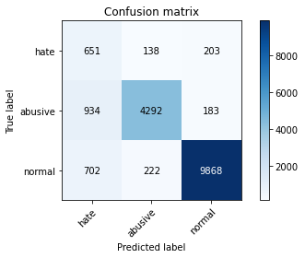

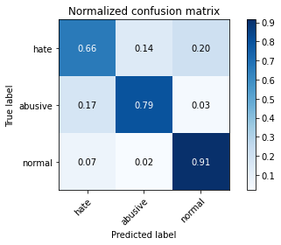

precision recall f1-score support

hate 0.28 0.66 0.40 992

abusive 0.92 0.79 0.85 5409

normal 0.96 0.91 0.94 10792

accuracy 0.86 17193

macro avg 0.72 0.79 0.73 17193

weighted avg 0.91 0.86 0.88 17193

average eval_loss: 0.4013472920760166, accuracy: 0.8614552434130169

0.5

training 1 epoch...

244.65032601356506 seconds used......

1 training finished! average train loss: 0.7778705267012792

total clf loss: 267.3667507022619 total adv loss: 154.4597862586379

evaluating...

Confusion matrix, without normalization

[[ 569 285 138]

[ 379 4928 102]

[1019 497 9276]]

Normalized confusion matrix

[[0.57358871 0.28729839 0.1391129 ]

[0.0700684 0.91107414 0.01885746]

[0.09442179 0.04605263 0.85952557]]

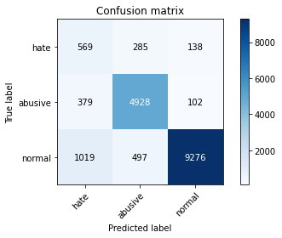

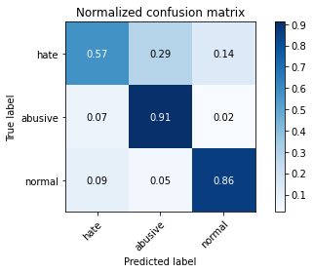

precision recall f1-score support

hate 0.29 0.57 0.38 992

abusive 0.86 0.91 0.89 5409

normal 0.97 0.86 0.91 10792

accuracy 0.86 17193

macro avg 0.71 0.78 0.73 17193

weighted avg 0.90 0.86 0.87 17193

average eval_loss: 0.44001899073983347, accuracy: 0.8592450415866922

training 2 epoch...

244.5037133693695 seconds used......

2 training finished! average train loss: 0.5817448766250374

total clf loss: 198.06768076121807 total adv loss: 119.29059994593263

evaluating...

Confusion matrix, without normalization

[[ 668 192 132]

[ 676 4602 131]

[1123 286 9383]]

Normalized confusion matrix

[[0.6733871 0.19354839 0.13306452]

[0.12497689 0.85080422 0.02421889]

[0.10405856 0.02650111 0.86944033]]

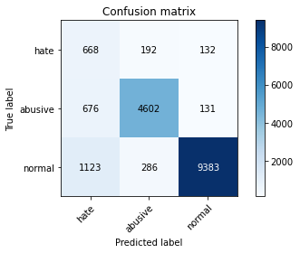

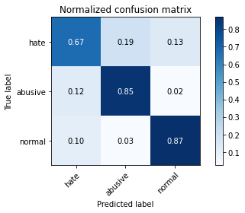

precision recall f1-score support

hate 0.27 0.67 0.39 992

abusive 0.91 0.85 0.88 5409

normal 0.97 0.87 0.92 10792

accuracy 0.85 17193

macro avg 0.72 0.80 0.73 17193

weighted avg 0.91 0.85 0.87 17193

average eval_loss: 0.40939328874093156, accuracy: 0.8522654568719827

0.6000000000000001

training 1 epoch...

244.45166277885437 seconds used......

1 training finished! average train loss: 0.8122685411040993

total clf loss: 266.73526291549206 total adv loss: 155.16616040468216

evaluating...

Confusion matrix, without normalization

[[ 588 210 194]

[ 497 4722 190]

[ 727 265 9800]]

Normalized confusion matrix

[[0.59274194 0.21169355 0.19556452]

[0.0918839 0.87298946 0.03512664]

[0.06736471 0.02455523 0.90808006]]

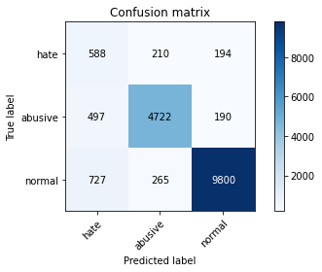

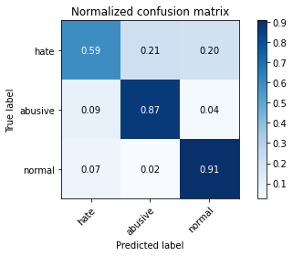

precision recall f1-score support

hate 0.32 0.59 0.42 992

abusive 0.91 0.87 0.89 5409

normal 0.96 0.91 0.93 10792

accuracy 0.88 17193

macro avg 0.73 0.79 0.75 17193

weighted avg 0.91 0.88 0.89 17193

average eval_loss: 0.3824390706541233, accuracy: 0.8788460419938346

training 2 epoch...

244.87862467765808 seconds used......

2 training finished! average train loss: 0.6140404868004823

total clf loss: 200.83799144625664 total adv loss: 118.63656925037503

evaluating...

Confusion matrix, without normalization

[[ 702 145 145]

[ 866 4422 121]

[1079 254 9459]]

Normalized confusion matrix

[[0.70766129 0.14616935 0.14616935]

[0.16010353 0.81752634 0.02237012]

[0.09998147 0.02353595 0.87648258]]

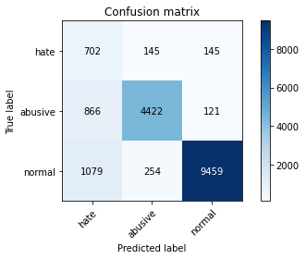

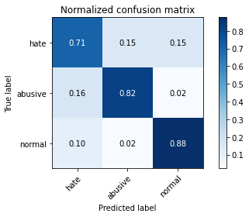

precision recall f1-score support

hate 0.27 0.71 0.39 992

abusive 0.92 0.82 0.86 5409

normal 0.97 0.88 0.92 10792

accuracy 0.85 17193

macro avg 0.72 0.80 0.72 17193

weighted avg 0.91 0.85 0.87 17193

average eval_loss: 0.44089071723784123, accuracy: 0.848194032455069

0.7000000000000001

training 1 epoch...

245.00824236869812 seconds used......

1 training finished! average train loss: 0.8870349179272189

total clf loss: 280.32713072001934 total adv loss: 160.89905698224902

evaluating...

Confusion matrix, without normalization

[[ 586 194 212]

[ 527 4708 174]

[ 640 345 9807]]

Normalized confusion matrix

[[0.59072581 0.19556452 0.21370968]

[0.09743021 0.87040118 0.03216861]

[0.05930319 0.03196812 0.90872869]]

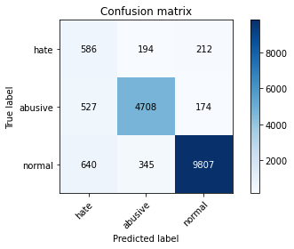

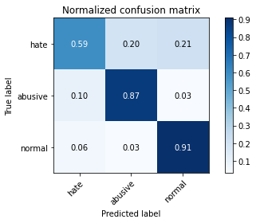

precision recall f1-score support

hate 0.33 0.59 0.43 992

abusive 0.90 0.87 0.88 5409

normal 0.96 0.91 0.93 10792

accuracy 0.88 17193

macro avg 0.73 0.79 0.75 17193

weighted avg 0.91 0.88 0.89 17193

average eval_loss: 0.3856588086849728, accuracy: 0.8783225731402315

training 2 epoch...

244.61332774162292 seconds used......

2 training finished! average train loss: 0.6469021042636501

total clf loss: 202.35698434710503 total adv loss: 120.31521272845566

evaluating...

Confusion matrix, without normalization

[[ 716 156 120]

[ 783 4491 135]

[1581 254 8957]]

Normalized confusion matrix

[[0.72177419 0.15725806 0.12096774]

[0.14475874 0.83028286 0.0249584 ]

[0.14649741 0.02353595 0.82996664]]

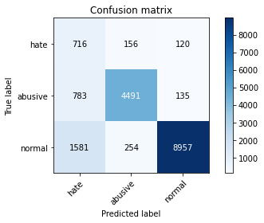

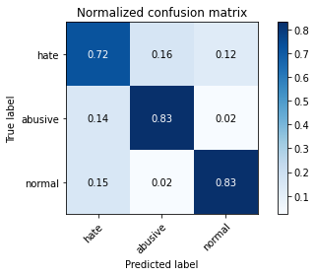

precision recall f1-score support

hate 0.23 0.72 0.35 992

abusive 0.92 0.83 0.87 5409

normal 0.97 0.83 0.90 10792

accuracy 0.82 17193

macro avg 0.71 0.79 0.71 17193

weighted avg 0.91 0.82 0.86 17193

average eval_loss: 0.46791507452726366, accuracy: 0.8238236491595416

0.8

training 1 epoch...

244.33306312561035 seconds used......

1 training finished! average train loss: 0.8836498046567155

total clf loss: 267.8617148846388 total adv loss: 154.49393190070987

evaluating...

Confusion matrix, without normalization

[[ 733 176 83]

[ 768 4569 72]

[2031 456 8305]]

Normalized confusion matrix

[[0.73891129 0.17741935 0.08366935]

[0.14198558 0.84470327 0.01331115]

[0.18819496 0.04225352 0.76955152]]

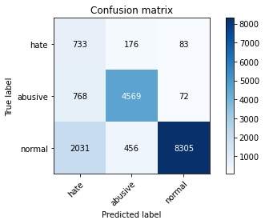

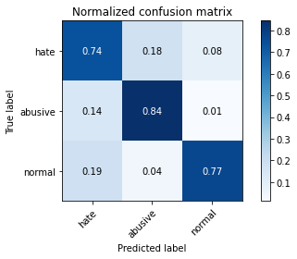

precision recall f1-score support

hate 0.21 0.74 0.32 992

abusive 0.88 0.84 0.86 5409

normal 0.98 0.77 0.86 10792

accuracy 0.79 17193

macro avg 0.69 0.78 0.68 17193

weighted avg 0.90 0.79 0.83 17193

average eval_loss: 0.5565315752355166, accuracy: 0.7914267434420985

training 2 epoch...

244.44132089614868 seconds used......

2 training finished! average train loss: 0.6732480212137877

total clf loss: 202.26680858433247 total adv loss: 119.97757874056697

evaluating...

Confusion matrix, without normalization

[[ 711 163 118]

[ 805 4487 117]

[1370 302 9120]]

Normalized confusion matrix

[[0.71673387 0.16431452 0.11895161]

[0.14882603 0.82954335 0.02163062]

[0.12694589 0.02798369 0.84507042]]

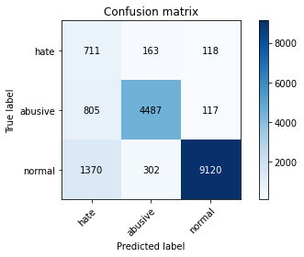

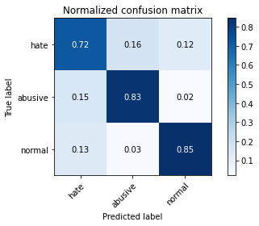

precision recall f1-score support

hate 0.25 0.72 0.37 992

abusive 0.91 0.83 0.87 5409

normal 0.97 0.85 0.91 10792

accuracy 0.83 17193

macro avg 0.71 0.80 0.71 17193

weighted avg 0.91 0.83 0.86 17193

average eval_loss: 0.45683528142439767, accuracy: 0.8327807828767522

0.9

training 1 epoch...

244.44037222862244 seconds used......

1 training finished! average train loss: 0.9259238152283309

total clf loss: 271.1551589369774 total adv loss: 154.47677186876535

evaluating...

Confusion matrix, without normalization

[[ 645 195 152]

[ 602 4669 138]

[ 904 319 9569]]

Normalized confusion matrix

[[0.65020161 0.19657258 0.15322581]

[0.11129599 0.86319098 0.02551303]

[0.08376575 0.02955893 0.88667532]]

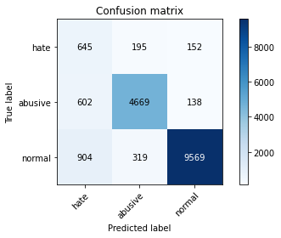

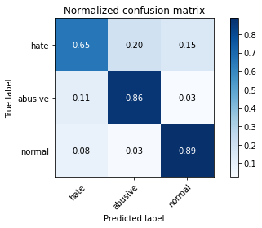

precision recall f1-score support

hate 0.30 0.65 0.41 992

abusive 0.90 0.86 0.88 5409

normal 0.97 0.89 0.93 10792

accuracy 0.87 17193

macro avg 0.72 0.80 0.74 17193

weighted avg 0.91 0.87 0.88 17193

average eval_loss: 0.4093375761321811, accuracy: 0.8656429942418427

training 2 epoch...

244.81265544891357 seconds used......

2 training finished! average train loss: 0.6868037102453864

total clf loss: 199.08857237547636 total adv loss: 116.85052691400051

evaluating...

Confusion matrix, without normalization

[[ 697 184 111]

[ 686 4625 98]

[1566 372 8854]]

Normalized confusion matrix

[[0.70262097 0.18548387 0.11189516]

[0.12682566 0.85505639 0.01811795]

[0.14510749 0.03446998 0.82042254]]

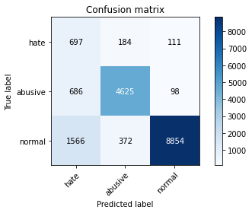

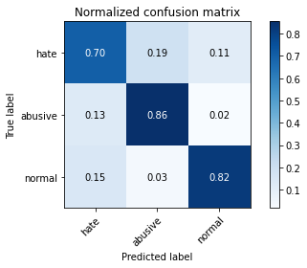

precision recall f1-score support

hate 0.24 0.70 0.35 992

abusive 0.89 0.86 0.87 5409

normal 0.98 0.82 0.89 10792

accuracy 0.82 17193

macro avg 0.70 0.79 0.71 17193

weighted avg 0.91 0.82 0.86 17193

average eval_loss: 0.48845851281008057, accuracy: 0.8245216076310127

1.0

training 1 epoch...

244.55411434173584 seconds used......

1 training finished! average train loss: 0.9623377289513702

total clf loss: 272.39651119709015 total adv loss: 153.91910285502672

evaluating...

Confusion matrix, without normalization

[[ 675 153 164]

[ 846 4399 164]

[ 945 271 9576]]

Normalized confusion matrix

[[0.68044355 0.15423387 0.16532258]

[0.15640599 0.81327417 0.03031984]

[0.08756486 0.02511119 0.88732394]]

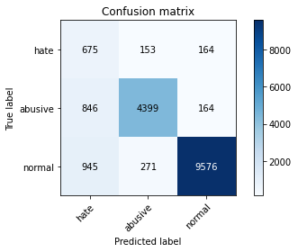

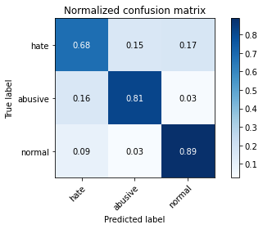

precision recall f1-score support

hate 0.27 0.68 0.39 992

abusive 0.91 0.81 0.86 5409

normal 0.97 0.89 0.93 10792

accuracy 0.85 17193

macro avg 0.72 0.79 0.73 17193

weighted avg 0.91 0.85 0.87 17193

average eval_loss: 0.42137720350089464, accuracy: 0.852090967254115

training 2 epoch...

1.4000000000000001

training 1 epoch...

245.97846269607544 seconds used......

1 training finished! average train loss: 1.088442100157318

total clf loss: 268.88095074892044 total adv loss: 152.35635805875063

evaluating...

Confusion matrix, without normalization

[[ 725 114 153]

[1070 4171 168]

[1140 203 9449]]

Normalized confusion matrix

[[0.73084677 0.11491935 0.15423387]

[0.19781845 0.7711222 0.03105935]

[0.1056338 0.01881023 0.87555597]]

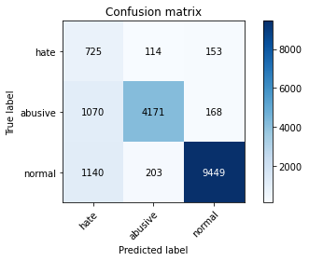

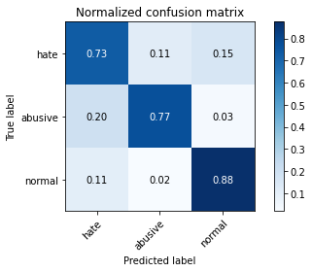

precision recall f1-score support

hate 0.25 0.73 0.37 992

abusive 0.93 0.77 0.84 5409

normal 0.97 0.88 0.92 10792

accuracy 0.83 17193

macro avg 0.71 0.79 0.71 17193

weighted avg 0.91 0.83 0.86 17193

average eval_loss: 0.4575118854641914, accuracy: 0.8343511894375618

training 2 epoch...

245.09229373931885 seconds used......

2 training finished! average train loss: 0.8178573994651336

total clf loss: 200.62204572558403 total adv loss: 115.49198917858303

evaluating...

Confusion matrix, without normalization

[[ 656 194 142]

[ 639 4642 128]

[1004 333 9455]]

Normalized confusion matrix

[[0.66129032 0.19556452 0.14314516]

[0.11813644 0.8581993 0.02366426]

[0.09303188 0.03085619 0.87611193]]

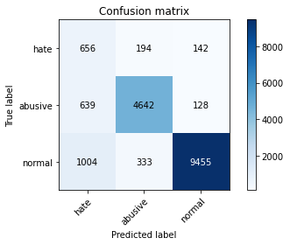

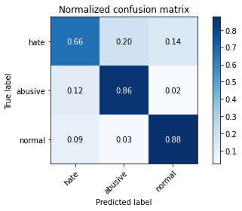

precision recall f1-score support

hate 0.29 0.66 0.40 992

abusive 0.90 0.86 0.88 5409

normal 0.97 0.88 0.92 10792

accuracy 0.86 17193

macro avg 0.72 0.80 0.73 17193

weighted avg 0.91 0.86 0.88 17193

average eval_loss: 0.40511060036545576, accuracy: 0.858081777467574

1.5

training 1 epoch...

245.39732360839844 seconds used......

1 training finished! average train loss: 1.142155648825131

total clf loss: 272.3067530095577 total adv loss: 155.77879909425974

evaluating...

Confusion matrix, without normalization

[[ 663 206 123]

[ 594 4696 119]

[1337 307 9148]]

Normalized confusion matrix

[[0.66834677 0.20766129 0.12399194]

[0.10981697 0.86818266 0.02200037]

[0.12388807 0.028447 0.84766494]]

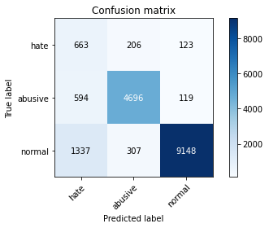

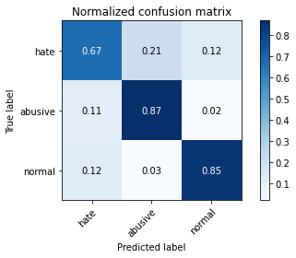

precision recall f1-score support

hate 0.26 0.67 0.37 992

abusive 0.90 0.87 0.88 5409

normal 0.97 0.85 0.91 10792

accuracy 0.84 17193

macro avg 0.71 0.79 0.72 17193

weighted avg 0.91 0.84 0.87 17193

average eval_loss: 0.4475369240828725, accuracy: 0.8437736288024196

training 2 epoch...

245.3063633441925 seconds used......

2 training finished! average train loss: 0.8499619960784912

total clf loss: 202.29457185417414 total adv loss: 116.15906190313399

evaluating...

Confusion matrix, without normalization

[[ 743 128 121]

[1007 4262 140]

[1626 216 8950]]

Normalized confusion matrix

[[0.74899194 0.12903226 0.12197581]

[0.1861712 0.78794602 0.02588279]

[0.15066716 0.02001483 0.82931801]]

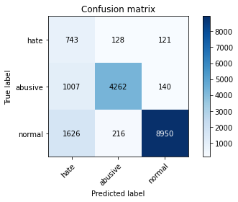

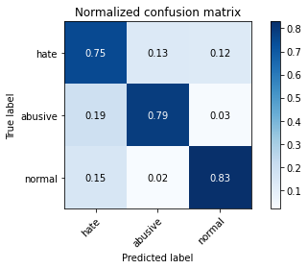

precision recall f1-score support

hate 0.22 0.75 0.34 992

abusive 0.93 0.79 0.85 5409

normal 0.97 0.83 0.89 10792

accuracy 0.81 17193

macro avg 0.71 0.79 0.70 17193

weighted avg 0.91 0.81 0.85 17193

average eval_loss: 0.5035756903072429, accuracy: 0.811667539114756

1.6

training 1 epoch...

245.28762435913086 seconds used......

1 training finished! average train loss: 1.1826634113056664

total clf loss: 272.73245814442635 total adv loss: 156.99214231967926

evaluating...

Confusion matrix, without normalization

[[ 691 179 122]

[ 700 4602 107]

[1525 272 8995]]

Normalized confusion matrix

[[0.69657258 0.18044355 0.12298387]

[0.12941394 0.85080422 0.01978185]

[0.14130838 0.02520385 0.83348777]]

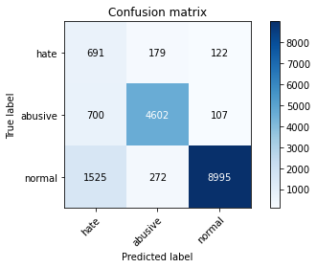

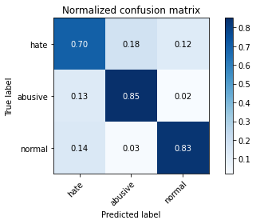

precision recall f1-score support

hate 0.24 0.70 0.35 992

abusive 0.91 0.85 0.88 5409

normal 0.98 0.83 0.90 10792

accuracy 0.83 17193

macro avg 0.71 0.79 0.71 17193

weighted avg 0.91 0.83 0.86 17193

average eval_loss: 0.476141859400411, accuracy: 0.8310358866980748

training 2 epoch...

245.41688990592957 seconds used......

2 training finished! average train loss: 0.8776909699558404

total clf loss: 202.86197481304407 total adv loss: 116.2219512257725

evaluating...

Confusion matrix, without normalization

[[ 755 131 106]

[1050 4252 107]

[1904 259 8629]]

Normalized confusion matrix

[[0.76108871 0.13205645 0.10685484]

[0.19412091 0.78609725 0.01978185]

[0.17642698 0.02399926 0.79957376]]

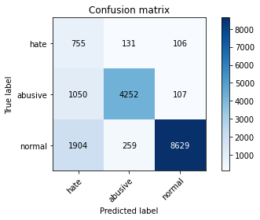

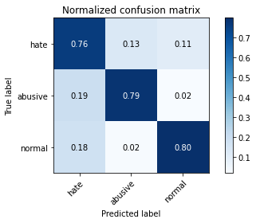

precision recall f1-score support

hate 0.20 0.76 0.32 992

abusive 0.92 0.79 0.85 5409

normal 0.98 0.80 0.88 10792

accuracy 0.79 17193

macro avg 0.70 0.78 0.68 17193

weighted avg 0.91 0.79 0.84 17193

average eval_loss: 0.540999511256814, accuracy: 0.79311347641482

1.7000000000000002

training 1 epoch...

245.42281198501587 seconds used......

1 training finished! average train loss: 1.208561735282364

total clf loss: 271.7157988846302 total adv loss: 155.10414239391685

evaluating...

Confusion matrix, without normalization

[[ 587 155 250]

[ 760 4382 267]

[ 499 212 10081]]

Normalized confusion matrix

[[0.59173387 0.15625 0.25201613]

[0.14050656 0.81013126 0.04936217]

[0.04623795 0.01964418 0.93411787]]

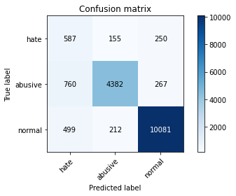

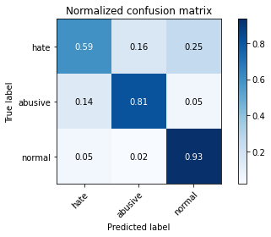

precision recall f1-score support

hate 0.32 0.59 0.41 992

abusive 0.92 0.81 0.86 5409

normal 0.95 0.93 0.94 10792

accuracy 0.88 17193

macro avg 0.73 0.78 0.74 17193

weighted avg 0.91 0.88 0.89 17193

average eval_loss: 0.3701932254962103, accuracy: 0.87535624963648

training 2 epoch...

245.2329351902008 seconds used......

2 training finished! average train loss: 0.9224502391120919

total clf loss: 206.09488643705845 total adv loss: 119.1473903618753

evaluating...

Confusion matrix, without normalization

[[ 677 202 113]

[ 666 4661 82]

[1637 513 8642]]

Normalized confusion matrix

[[0.68245968 0.20362903 0.11391129]

[0.12312812 0.86171196 0.01515992]

[0.15168643 0.04753521 0.80077835]]

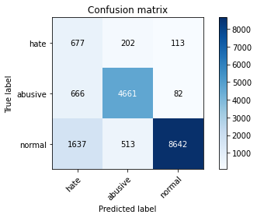

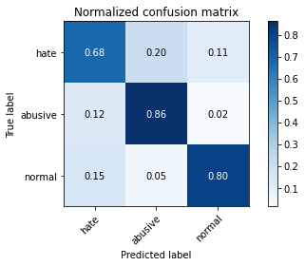

precision recall f1-score support

hate 0.23 0.68 0.34 992

abusive 0.87 0.86 0.86 5409

normal 0.98 0.80 0.88 10792

accuracy 0.81 17193

macro avg 0.69 0.78 0.70 17193

weighted avg 0.90 0.81 0.84 17193

average eval_loss: 0.5103602923279584, accuracy: 0.8131216192636538

1.8

training 1 epoch...

245.5155735015869 seconds used......

1 training finished! average train loss: 1.256873484187955

total clf loss: 274.4390300810337 total adv loss: 156.86440681666136

evaluating...

Confusion matrix, without normalization

[[ 714 150 128]

[ 863 4428 118]

[1534 269 8989]]

Normalized confusion matrix

[[0.71975806 0.15120968 0.12903226]

[0.1595489 0.81863561 0.02181549]

[0.14214233 0.02492587 0.8329318 ]]

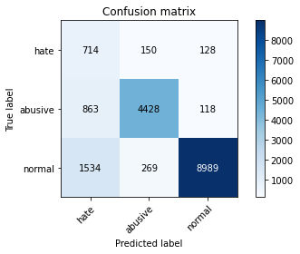

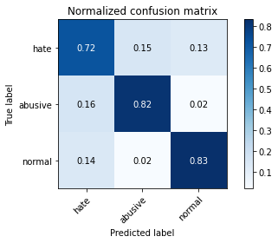

precision recall f1-score support

hate 0.23 0.72 0.35 992

abusive 0.91 0.82 0.86 5409

normal 0.97 0.83 0.90 10792

accuracy 0.82 17193

macro avg 0.71 0.79 0.70 17193

weighted avg 0.91 0.82 0.86 17193

average eval_loss: 0.4691994775693084, accuracy: 0.8219042633629966

training 2 epoch...

245.6108546257019 seconds used......

2 training finished! average train loss: 0.9568819284573634

total clf loss: 208.36946314573288 total adv loss: 119.73846497759223

evaluating...

Confusion matrix, without normalization

[[ 683 147 162]

[ 879 4381 149]

[1026 241 9525]]

Normalized confusion matrix

[[0.68850806 0.14818548 0.16330645]

[0.16250693 0.80994639 0.02754668]

[0.09507042 0.02233136 0.88259822]]

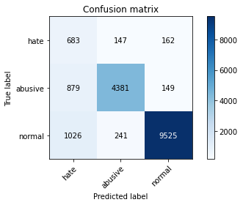

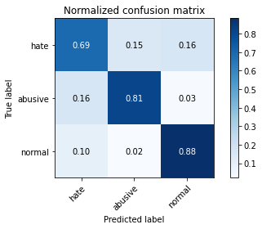

precision recall f1-score support

hate 0.26 0.69 0.38 992

abusive 0.92 0.81 0.86 5409

normal 0.97 0.88 0.92 10792

accuracy 0.85 17193

macro avg 0.72 0.79 0.72 17193

weighted avg 0.91 0.85 0.87 17193

average eval_loss: 0.42933109630505706, accuracy: 0.8485430116908044

1.9000000000000001

training 1 epoch...

245.54506707191467 seconds used......

1 training finished! average train loss: 1.2805589149552596

total clf loss: 273.60211174190044 total adv loss: 154.57131091877818

evaluating...

Confusion matrix, without normalization

[[ 611 184 197]

[ 636 4617 156]

[ 668 318 9806]]

Normalized confusion matrix

[[0.61592742 0.18548387 0.19858871]

[0.11758181 0.85357737 0.02884082]

[0.0618977 0.02946627 0.90863603]]

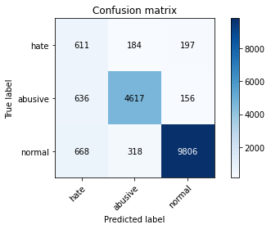

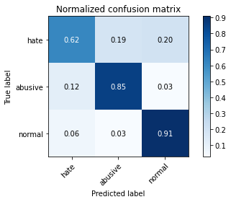

precision recall f1-score support

hate 0.32 0.62 0.42 992

abusive 0.90 0.85 0.88 5409

normal 0.97 0.91 0.94 10792

accuracy 0.87 17193

macro avg 0.73 0.79 0.74 17193

weighted avg 0.91 0.87 0.89 17193

average eval_loss: 0.378475200194259, accuracy: 0.8744256383411854

training 2 epoch...

245.5742700099945 seconds used......

2 training finished! average train loss: 0.9632316576169792

total clf loss: 203.9240997582674 total adv loss: 117.25659349188209

evaluating...

Confusion matrix, without normalization

[[ 685 159 148]

[ 859 4428 122]

[1163 244 9385]]

Normalized confusion matrix

[[0.69052419 0.16028226 0.14919355]

[0.15880939 0.81863561 0.022555 ]

[0.10776501 0.02260934 0.86962565]]

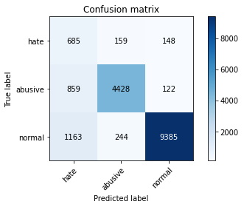

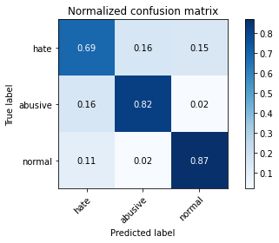

precision recall f1-score support

hate 0.25 0.69 0.37 992

abusive 0.92 0.82 0.86 5409

normal 0.97 0.87 0.92 10792

accuracy 0.84 17193

macro avg 0.71 0.79 0.72 17193

weighted avg 0.91 0.84 0.87 17193

average eval_loss: 0.43366196839961896, accuracy: 0.8432501599488164

2.0

training 1 epoch...

245.413268327713 seconds used......

1 training finished! average train loss: 1.3252769971674236

total clf loss: 276.6595096439123 total adv loss: 155.21909971907735

evaluating...

Confusion matrix, without normalization

[[ 670 183 139]

[ 686 4583 140]

[1210 274 9308]]

Normalized confusion matrix

[[0.67540323 0.18447581 0.14012097]

[0.12682566 0.84729155 0.02588279]

[0.11212009 0.02538918 0.86249073]]

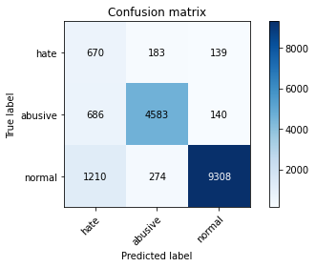

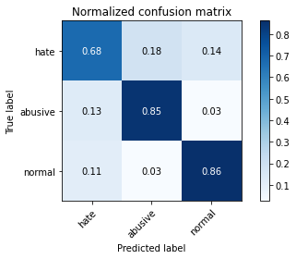

precision recall f1-score support

hate 0.26 0.68 0.38 992

abusive 0.91 0.85 0.88 5409

normal 0.97 0.86 0.91 10792

accuracy 0.85 17193

macro avg 0.71 0.80 0.72 17193

weighted avg 0.91 0.85 0.87 17193

average eval_loss: 0.43718958332441576, accuracy: 0.8469144419240389

training 2 epoch...

245.4348771572113 seconds used......

2 training finished! average train loss: 0.9936491062624998

total clf loss: 205.23733606934547 total adv loss: 117.47460937127471

evaluating...

Confusion matrix, without normalization

[[ 760 145 87]

[ 901 4431 77]

[2469 300 8023]]

Normalized confusion matrix

[[0.76612903 0.14616935 0.08770161]

[0.16657423 0.81919024 0.01423553]

[0.22878058 0.02779837 0.74342105]]

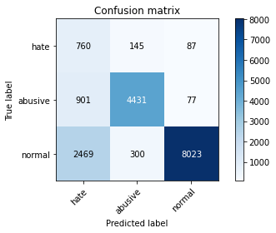

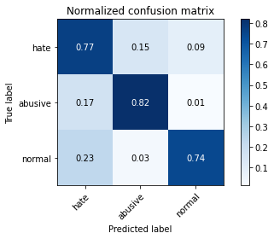

precision recall f1-score support

hate 0.18 0.77 0.30 992

abusive 0.91 0.82 0.86 5409

normal 0.98 0.74 0.85 10792

accuracy 0.77 17193

macro avg 0.69 0.78 0.67 17193

weighted avg 0.91 0.77 0.82 17193

average eval_loss: 0.5884040016594321, accuracy: 0.768568603501425

2.1

training 1 epoch...

245.58055472373962 seconds used......

1 training finished! average train loss: 1.352836663782193

total clf loss: 274.4025808721781 total adv loss: 154.71622713655233

evaluating...

Confusion matrix, without normalization

[[ 760 115 117]

[1200 4098 111]

[1446 226 9120]]

Normalized confusion matrix

[[0.76612903 0.11592742 0.11794355]

[0.22185247 0.75762618 0.02052135]

[0.13398814 0.02094144 0.84507042]]

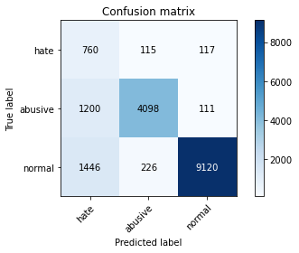

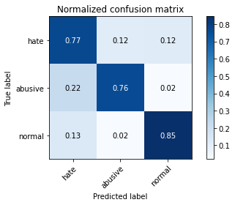

precision recall f1-score support

hate 0.22 0.77 0.35 992

abusive 0.92 0.76 0.83 5409

normal 0.98 0.85 0.91 10792

accuracy 0.81 17193

macro avg 0.71 0.79 0.69 17193

weighted avg 0.92 0.81 0.85 17193

average eval_loss: 0.4962720160914022, accuracy: 0.813005292851742

training 2 epoch...

245.63935232162476 seconds used......

2 training finished! average train loss: 1.0130971667459803

total clf loss: 203.58650863915682 total adv loss: 116.76930823922157

evaluating...

Confusion matrix, without normalization

[[ 627 210 155]

[ 638 4639 132]

[ 952 320 9520]]

Normalized confusion matrix

[[0.63205645 0.21169355 0.15625 ]

[0.11795156 0.85764467 0.02440377]

[0.08821349 0.02965159 0.88213491]]

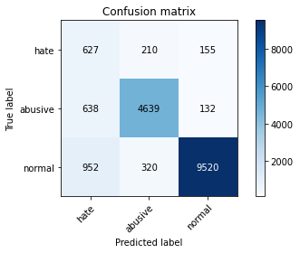

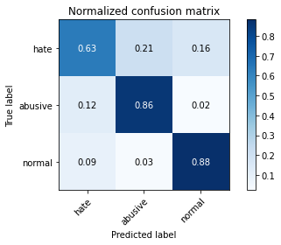

precision recall f1-score support

hate 0.28 0.63 0.39 992

abusive 0.90 0.86 0.88 5409

normal 0.97 0.88 0.92 10792

accuracy 0.86 17193

macro avg 0.72 0.79 0.73 17193

weighted avg 0.91 0.86 0.88 17193

average eval_loss: 0.40688556712553947, accuracy: 0.8600011632641191

2.2

training 1 epoch...

245.55749773979187 seconds used......

1 training finished! average train loss: 1.397432769663447

total clf loss: 276.07857029139996 total adv loss: 155.90188203379512

evaluating...

Confusion matrix, without normalization

[[ 550 176 266]

[ 609 4539 261]

[ 362 233 10197]]

Normalized confusion matrix

[[0.55443548 0.17741935 0.26814516]

[0.11259013 0.83915696 0.04825291]

[0.03354337 0.02159007 0.94486657]]

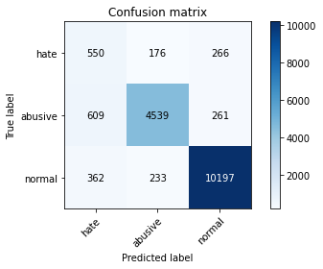

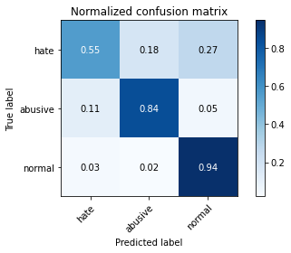

precision recall f1-score support

hate 0.36 0.55 0.44 992

abusive 0.92 0.84 0.88 5409

normal 0.95 0.94 0.95 10792

accuracy 0.89 17193

macro avg 0.74 0.78 0.75 17193

weighted avg 0.91 0.89 0.90 17193

average eval_loss: 0.346773578555778, accuracy: 0.8890827662420753

training 2 epoch...

245.48683190345764 seconds used......

2 training finished! average train loss: 1.0455434674872233

total clf loss: 206.98742985725403 total adv loss: 116.4492364116013

evaluating...

Confusion matrix, without normalization

[[ 730 180 82]

[ 849 4492 68]

[2359 430 8003]]

Normalized confusion matrix

[[0.7358871 0.18145161 0.08266129]

[0.15696062 0.83046774 0.01257164]

[0.21858784 0.03984433 0.74156783]]

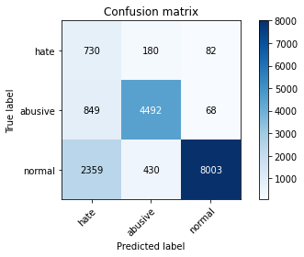

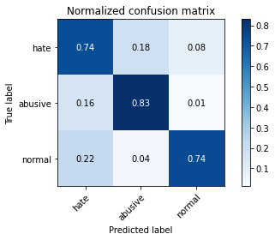

precision recall f1-score support

hate 0.19 0.74 0.30 992

abusive 0.88 0.83 0.85 5409

normal 0.98 0.74 0.84 10792

accuracy 0.77 17193

macro avg 0.68 0.77 0.67 17193

weighted avg 0.90 0.77 0.82 17193

average eval_loss: 0.6056924265657746, accuracy: 0.76920839876694

2.3000000000000003

training 1 epoch...

245.55296730995178 seconds used......

1 training finished! average train loss: 1.4353135502634415

total clf loss: 273.85335107147694 total adv loss: 157.38719868659973

evaluating...

Confusion matrix, without normalization

[[ 554 242 196]

[ 444 4745 220]

[ 632 339 9821]]

Normalized confusion matrix

[[0.55846774 0.24395161 0.19758065]

[0.08208541 0.87724163 0.04067295]

[0.0585619 0.03141216 0.91002595]]

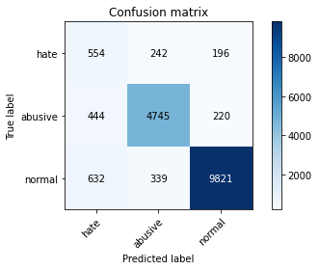

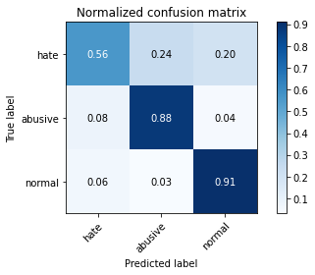

precision recall f1-score support

hate 0.34 0.56 0.42 992

abusive 0.89 0.88 0.88 5409

normal 0.96 0.91 0.93 10792

accuracy 0.88 17193

macro avg 0.73 0.78 0.75 17193

weighted avg 0.90 0.88 0.89 17193

average eval_loss: 0.3697368652928014, accuracy: 0.8794276740533938

training 2 epoch...

245.7587194442749 seconds used......

2 training finished! average train loss: 1.0532821149777614

total clf loss: 203.47517912089825 total adv loss: 114.40382820367813

evaluating...

Confusion matrix, without normalization

[[ 726 150 116]

[ 865 4430 114]

[1560 251 8981]]

Normalized confusion matrix

[[0.73185484 0.15120968 0.11693548]

[0.15991865 0.81900536 0.02107598]

[0.14455152 0.02325797 0.83219051]]

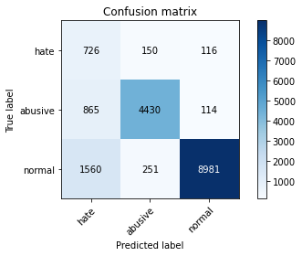

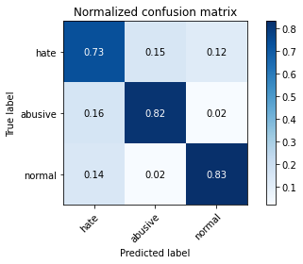

precision recall f1-score support

hate 0.23 0.73 0.35 992

abusive 0.92 0.82 0.87 5409

normal 0.98 0.83 0.90 10792

accuracy 0.82 17193

macro avg 0.71 0.79 0.70 17193

weighted avg 0.91 0.82 0.86 17193

average eval_loss: 0.4838271079714908, accuracy: 0.822253242598732

2.4000000000000004

training 1 epoch...

245.65827584266663 seconds used......

1 training finished! average train loss: 1.4496576989881071

total clf loss: 271.30970050394535 total adv loss: 154.5369350835681

evaluating...

Confusion matrix, without normalization

[[ 717 168 107]

[ 793 4522 94]

[1692 296 8804]]

Normalized confusion matrix

[[0.72278226 0.16935484 0.1078629 ]

[0.14660751 0.83601405 0.01737844]

[0.1567828 0.02742772 0.81578947]]

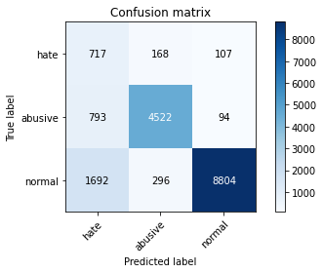

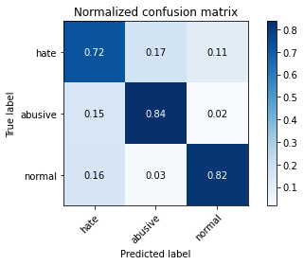

precision recall f1-score support

hate 0.22 0.72 0.34 992

abusive 0.91 0.84 0.87 5409

normal 0.98 0.82 0.89 10792

accuracy 0.82 17193

macro avg 0.70 0.79 0.70 17193

weighted avg 0.91 0.82 0.85 17193

average eval_loss: 0.481082002420065, accuracy: 0.8167859012388763

training 2 epoch...

245.72166395187378 seconds used......

2 training finished! average train loss: 1.1102931676411467

total clf loss: 207.27297608554363 total adv loss: 118.57786913216114

evaluating...

Confusion matrix, without normalization

[[ 687 140 165]

[ 823 4409 177]

[ 911 226 9655]]

Normalized confusion matrix

[[0.69254032 0.14112903 0.16633065]

[0.15215382 0.81512294 0.03272324]

[0.08441438 0.02094144 0.89464418]]

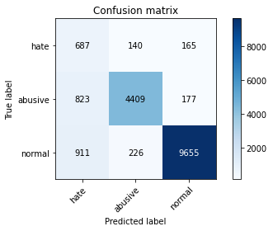

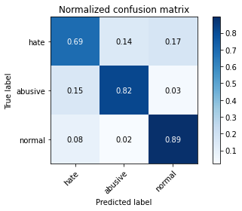

precision recall f1-score support

hate 0.28 0.69 0.40 992

abusive 0.92 0.82 0.87 5409

normal 0.97 0.89 0.93 10792

accuracy 0.86 17193

macro avg 0.72 0.80 0.73 17193

weighted avg 0.91 0.86 0.88 17193

average eval_loss: 0.4006600664971873, accuracy: 0.8579654510556622

2.5

training 1 epoch...

245.73423838615417 seconds used......

1 training finished! average train loss: 1.4830216071810194

total clf loss: 270.9222988784313 total adv loss: 154.42250876873732

evaluating...

Confusion matrix, without normalization

[[ 680 176 136]

[ 703 4565 141]

[1263 264 9265]]

Normalized confusion matrix

[[0.68548387 0.17741935 0.13709677]

[0.12996857 0.84396376 0.02606767]

[0.11703113 0.02446256 0.8585063 ]]

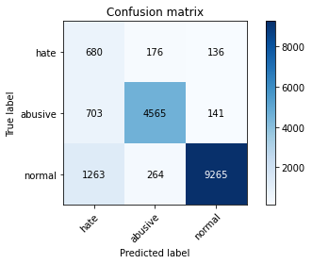

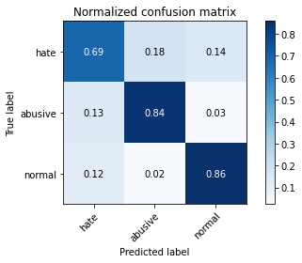

precision recall f1-score support

hate 0.26 0.69 0.37 992

abusive 0.91 0.84 0.88 5409

normal 0.97 0.86 0.91 10792

accuracy 0.84 17193

macro avg 0.71 0.80 0.72 17193

weighted avg 0.91 0.84 0.87 17193

average eval_loss: 0.4386417389089285, accuracy: 0.8439481184202873

training 2 epoch...

245.5231111049652 seconds used......

2 training finished! average train loss: 1.134672112510651

total clf loss: 209.4177715703845 total adv loss: 117.296789791435

evaluating...

Confusion matrix, without normalization

[[ 723 126 143]

[1062 4206 141]

[1198 237 9357]]

Normalized confusion matrix

[[0.72883065 0.12701613 0.14415323]

[0.19633943 0.7775929 0.02606767]

[0.11100815 0.02196071 0.86703113]]

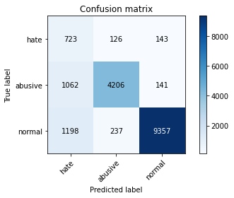

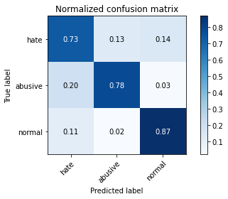

precision recall f1-score support

hate 0.24 0.73 0.36 992

abusive 0.92 0.78 0.84 5409

normal 0.97 0.87 0.92 10792

accuracy 0.83 17193

macro avg 0.71 0.79 0.71 17193

weighted avg 0.91 0.83 0.86 17193

average eval_loss: 0.44728072486644566, accuracy: 0.830919560286163

2.6

training 1 epoch...

245.66861391067505 seconds used......

1 training finished! average train loss: 1.5368415254502479

total clf loss: 275.324062153697 total adv loss: 155.9602880626917

evaluating...

Confusion matrix, without normalization

[[ 729 177 86]

[ 749 4559 101]

[2073 266 8453]]

Normalized confusion matrix

[[0.73487903 0.17842742 0.08669355]

[0.13847292 0.8428545 0.01867258]

[0.19208673 0.02464789 0.78326538]]

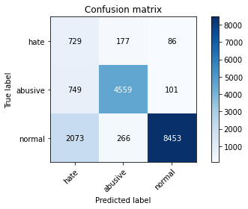

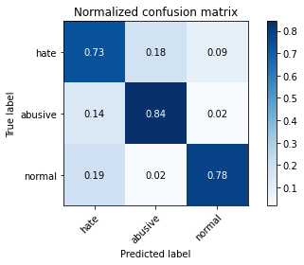

precision recall f1-score support

hate 0.21 0.73 0.32 992

abusive 0.91 0.84 0.88 5409

normal 0.98 0.78 0.87 10792

accuracy 0.80 17193

macro avg 0.70 0.79 0.69 17193

weighted avg 0.91 0.80 0.84 17193

average eval_loss: 0.5220028914684474, accuracy: 0.7992206130401908

training 2 epoch...

245.74321722984314 seconds used......

2 training finished! average train loss: 1.1592550135425737

total clf loss: 207.7414424419403 total adv loss: 117.61866943538189

evaluating...

Confusion matrix, without normalization

[[ 696 159 137]

[ 797 4473 139]

[1347 271 9174]]

Normalized confusion matrix

[[0.7016129 0.16028226 0.13810484]

[0.14734701 0.82695507 0.02569791]

[0.12481468 0.02511119 0.85007413]]

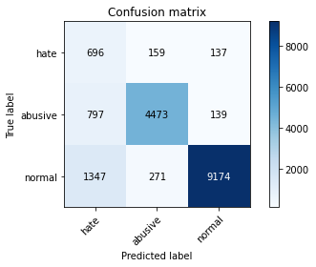

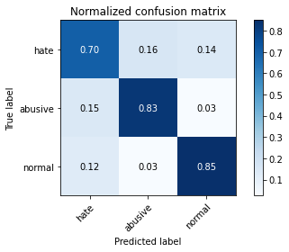

precision recall f1-score support

hate 0.25 0.70 0.36 992

abusive 0.91 0.83 0.87 5409

normal 0.97 0.85 0.91 10792

accuracy 0.83 17193

macro avg 0.71 0.79 0.71 17193

weighted avg 0.91 0.83 0.86 17193

average eval_loss: 0.45509640598712964, accuracy: 0.83423486302565

2.7

training 1 epoch...

245.73852562904358 seconds used......

1 training finished! average train loss: 1.5585738251629049

total clf loss: 276.51035226881504 total adv loss: 153.31031243130565

evaluating...

Confusion matrix, without normalization

[[ 663 179 150]

[ 712 4555 142]

[1187 280 9325]]

Normalized confusion matrix

[[0.66834677 0.18044355 0.15120968]

[0.13163246 0.84211499 0.02625254]

[0.10998888 0.02594514 0.86406597]]

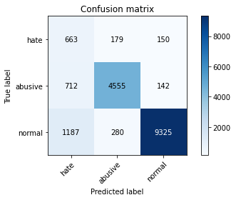

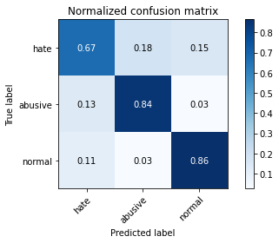

precision recall f1-score support

hate 0.26 0.67 0.37 992

abusive 0.91 0.84 0.87 5409

normal 0.97 0.86 0.91 10792

accuracy 0.85 17193

macro avg 0.71 0.79 0.72 17193

weighted avg 0.91 0.85 0.87 17193

average eval_loss: 0.4456549319070439, accuracy: 0.8458675042168324

training 2 epoch...

245.78545689582825 seconds used......

2 training finished! average train loss: 1.198789154164678

total clf loss: 211.14000341296196 total adv loss: 118.49021654948592

evaluating...

Confusion matrix, without normalization

[[ 565 229 198]

[ 467 4778 164]

[ 624 396 9772]]

Normalized confusion matrix

[[0.56955645 0.23084677 0.19959677]

[0.08633759 0.88334258 0.03031984]

[0.05782061 0.03669385 0.90548554]]

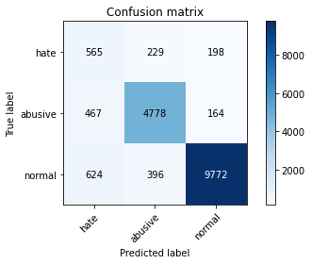

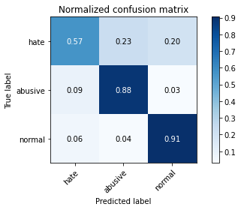

precision recall f1-score support

hate 0.34 0.57 0.43 992

abusive 0.88 0.88 0.88 5409

normal 0.96 0.91 0.93 10792

accuracy 0.88 17193

macro avg 0.73 0.79 0.75 17193

weighted avg 0.90 0.88 0.89 17193

average eval_loss: 0.3613079993357492, accuracy: 0.8791368580236143

2.8000000000000003

training 1 epoch...

245.93533778190613 seconds used......

1 training finished! average train loss: 1.5974735470980608

total clf loss: 272.20255096256733 total adv loss: 155.52794202417135

evaluating...

Confusion matrix, without normalization

[[ 556 198 238]

[ 518 4669 222]

[ 419 256 10117]]

Normalized confusion matrix

[[0.56048387 0.19959677 0.23991935]

[0.09576632 0.86319098 0.04104271]

[0.03882506 0.02372128 0.93745367]]

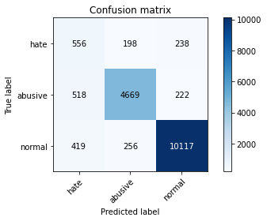

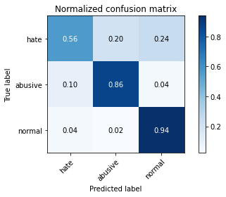

precision recall f1-score support

hate 0.37 0.56 0.45 992

abusive 0.91 0.86 0.89 5409

normal 0.96 0.94 0.95 10792

accuracy 0.89 17193

macro avg 0.75 0.79 0.76 17193

weighted avg 0.91 0.89 0.90 17193

average eval_loss: 0.3476261610208556, accuracy: 0.8923399057756064

training 2 epoch...

245.7442193031311 seconds used......

2 training finished! average train loss: 1.2080683953067788

total clf loss: 206.44754840433598 total adv loss: 117.40241259150207

evaluating...

Confusion matrix, without normalization

[[ 692 164 136]

[ 784 4462 163]

[1373 229 9190]]

Normalized confusion matrix

[[0.69758065 0.16532258 0.13709677]

[0.14494361 0.82492143 0.03013496]

[0.12722387 0.02121942 0.85155671]]

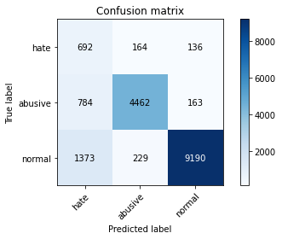

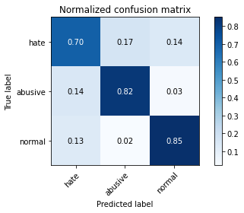

precision recall f1-score support

hate 0.24 0.70 0.36 992

abusive 0.92 0.82 0.87 5409

normal 0.97 0.85 0.91 10792

accuracy 0.83 17193

macro avg 0.71 0.79 0.71 17193

weighted avg 0.91 0.83 0.86 17193

average eval_loss: 0.46461039729589637, accuracy: 0.8342930262316058

2.9000000000000004

training 1 epoch...

245.93739557266235 seconds used......

1 training finished! average train loss: 1.6451560655781163

total clf loss: 278.31997169554234 total adv loss: 155.33936174958944

evaluating...

Confusion matrix, without normalization

[[ 668 194 130]

[ 676 4608 125]

[1209 349 9234]]

Normalized confusion matrix

[[0.6733871 0.19556452 0.13104839]

[0.12497689 0.85191348 0.02310963]

[0.11202743 0.03233877 0.8556338 ]]

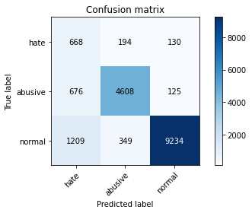

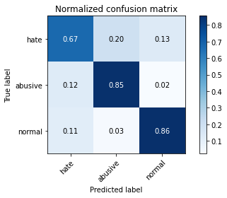

precision recall f1-score support

hate 0.26 0.67 0.38 992

abusive 0.89 0.85 0.87 5409

normal 0.97 0.86 0.91 10792

accuracy 0.84 17193

macro avg 0.71 0.79 0.72 17193

weighted avg 0.91 0.84 0.87 17193

average eval_loss: 0.45118703720874564, accuracy: 0.8439481184202873

training 2 epoch...

245.92331290245056 seconds used......

2 training finished! average train loss: 1.2440260916477401

total clf loss: 208.44854645431042 total adv loss: 118.15689638629556

evaluating...

Confusion matrix, without normalization

[[ 748 148 96]

[ 950 4359 100]

[2010 267 8515]]

Normalized confusion matrix

[[0.75403226 0.14919355 0.09677419]

[0.1756332 0.80587909 0.01848771]

[0.18624907 0.02474055 0.78901038]]

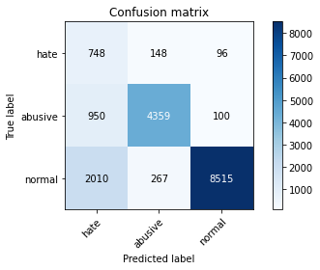

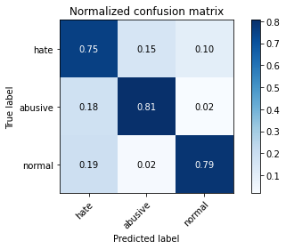

precision recall f1-score support

hate 0.20 0.75 0.32 992

abusive 0.91 0.81 0.86 5409

normal 0.98 0.79 0.87 10792

accuracy 0.79 17193

macro avg 0.70 0.78 0.68 17193

weighted avg 0.91 0.79 0.84 17193

average eval_loss: 0.5462076500751252, accuracy: 0.7922991915314372

3.0

training 1 epoch...

245.70641994476318 seconds used......

1 training finished! average train loss: 1.6432827258352232

total clf loss: 274.4025484621525 total adv loss: 151.19056567549706

evaluating...

Confusion matrix, without normalization

[[ 736 130 126]

[ 965 4298 146]

[1412 231 9149]]

Normalized confusion matrix

[[0.74193548 0.13104839 0.12701613]

[0.17840636 0.79460159 0.02699205]

[0.13083766 0.02140474 0.8477576 ]]

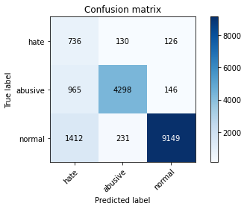

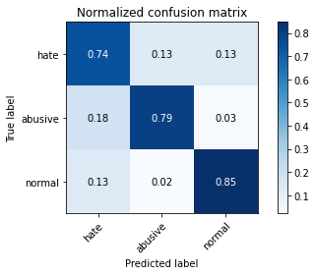

precision recall f1-score support

hate 0.24 0.74 0.36 992

abusive 0.92 0.79 0.85 5409

normal 0.97 0.85 0.91 10792

accuracy 0.82 17193

macro avg 0.71 0.79 0.71 17193

weighted avg 0.91 0.82 0.86 17193

average eval_loss: 0.45881232539581696, accuracy: 0.824928750072704

training 2 epoch...

245.71081471443176 seconds used......

2 training finished! average train loss: 1.257081344891886

total clf loss: 209.0997230708599 total adv loss: 115.9291037991643

evaluating...

Confusion matrix, without normalization

[[ 623 178 191]

[ 644 4567 198]

[ 759 264 9769]]

Normalized confusion matrix

[[0.62802419 0.17943548 0.19254032]

[0.11906082 0.84433352 0.03660566]

[0.07032987 0.02446256 0.90520756]]

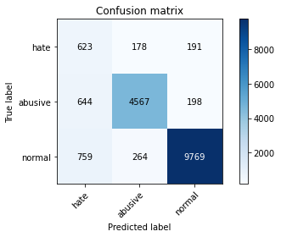

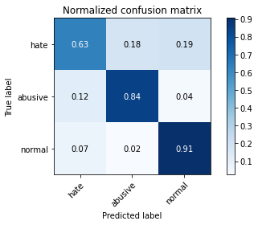

precision recall f1-score support

hate 0.31 0.63 0.41 992

abusive 0.91 0.84 0.88 5409

normal 0.96 0.91 0.93 10792

accuracy 0.87 17193

macro avg 0.73 0.79 0.74 17193

weighted avg 0.91 0.87 0.89 17193

average eval_loss: 0.3832907856896866, accuracy: 0.8700633978944919